Joe McCay

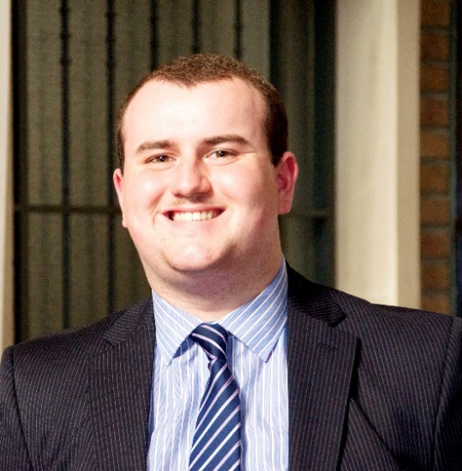
Personal Details
ADDRESS: 99 Station Street
Misterton
Doncaster
South Yorkshire
DN10 4DB
EMAIL: joe.mccay@outlook.com
MOBILE PHONE NUMBER: 07555104019
Personal Statement
I am 22 years old and since leaving school I have spent my time training to be a Catholic priest. This has included me spending time volunteering in a variety of organisations which assist vulnerable people and also studying philosophy and theology at a seminary. I have worked successfully with people from different backgrounds, ages, cultures and beliefs to help accomplish everyday life tasks and to maintain their positive mental attitudes. I have a strong belief in humour as a good way to connect with people of all age groups and I am friendly, inclusive and understanding. I have purposefully ensured that reliability and punctuality are key aspects to show my commitment and determination in seeing tasks through and in encouraging others. I believe that treating people with respect and politeness, dignity and encouragement are skills that transfer to all work situations.
Work Experience
Allen Hall Seminary, London: September 2014 – April 2017 which included the following placements and experiences:
- The Most Sacred Heart of Jesus Catholic Church, Nottingham: September 2016 – April 2017
- Saint Charles Borromeo Catholic Church, Glossop: July 2015
- Saint Anne’s Care Home, London: September 2015 – June 2016
- Saint Mary’s Catholic Church, Chelsea, London: September 2014 – June 2015
- Part of a team which ran all aspects of a worshipping community including strategy, administration, delivery of services and leading catechesis.
- Volunteered at Sacred Heart Catholic Voluntary Academy, Carlton, Nottingham. Involving tasks such as assisting in the delivery of the curriculum and interventions, supervision of break times, leadership of an after school club, supporting staff on trips including residential and exercising safe practice and safeguarding.
- Volunteered in the Spiritual and Pastoral Care Department of a major NHS trust (City Hospital, Nottingham). Involving tasks such as being part of a multi-disciplinary team, listening, empathy, teamwork and conflict resolution.
- Being part of a team managing a process of change involving the closure of a building and the relocation to another shared facility.
- Pastoral care of a worshipping community by visiting housebound and bereaved families, taking them Holy Communion.
- Leading a group of people in the act of worship and sacramental preparation by praying and teaching.
- Attending to the spiritual and physical needs of the sick and the elderly by praying, listening and helping them get to their desired destination.
- Master of Ceremonies (main altar server) which involved leading groups of young people through the completion of a religious service.
The Cathedral Church of Saint Barnabas, Nottingham: March 2014
- Volunteered in the Spiritual and Pastoral Care Department of a major NHS trust. (Queens Medical Centre, Nottingham). Involving tasks such as organisation, good time keeping and flexibility.
- Volunteered in the Multi Faith Department of HM Prison Nottingham. Involving tasks such organisation, concentration and emphasis on equality.
Saint Bernadette’s Catholic Church, Scunthorpe: September 2013 – July 2014
- Involved in assisting the Holy Communion programme. Involving tasks such as being responsible with young children and being able to teach and manage a group of children.
Holy Souls Catholic Church, Scunthorpe: September 2013 – July 2014
- Pastoral care of the worshipping community by taking Holy Communion to the housebound.
- Volunteered at Saint Bede’s Catholic Voluntary Academy, Scunthorpe. Involving tasks such as leading prayer and activities in a lunch time school club and assisting in RE lessons.
The Forge Project, Scunthorpe: September 2013 – July 2014
- Volunteered by attending to the specific needs of the homeless, abused, isolated and those with addictions. This included tasks such as helping people to read and write, assisting in the completion of forms and enhancing computer literacy.
- Part of a team of volunteers which prepared and served meals and refreshments.
The Briars Catholic Youth Retreat Centre, Matlock: February 2013 (1 week)
- Lead a group of young people in games, tasks and prayer. This involved showing an equilibrium of responsible and jovial approaches.
Hong Kong Chef Chinese Takeaway, Misterton: October 2013
- A receptionist. Involving tasks such as creating a good first impression by greeting customers in person and on the telephone and guaranteeing that they had a positive experience to improve customer retention.
Skills and Achievements
- Captain of my local football team (Retford United 2001-2014). This involved assisting and leading training sessions.
- DBS checked
- Full UK Driving Licence
- Received the Ministry of Reader in my third year of training for the Catholic Priesthood.
Education and Qualifications
The McAuley Catholic High School, Doncaster: 2006 – 2013
10 GCSE’s including Maths and English.
1 AS Level in English Language.
3 A Levels including English Literature.
References available on request.

